------------------ASSIGNMENT-SQL-------------------

QUERIES(11-25)

11.*Write a query which will display the customer id, customer name, account no, account type, activation date,

bank name whose account will be activated on '10-APR-2012'

SELECT C.CUSTOMER_ID,C.CUSTOMER_NAME,A.ACCOUNT_NO,A.ACCOUNT_TYPE,A.ACTIVATION_DATE,B.BANK_NAME

FROM ACCOUNT_INFO A, CUSTOMER_PERSONAL_INFO C, BANK_INFO B

WHERE C.CUSTOMER_ID=A.CUSTOMER_ID AND A.IFSC_CODE=B.IFSC_CODE AND ACTIVATION_DATE='10-APR-2012';

11.PNG

12.*Write a query which will display account number, customer id, customer name, bank name, branch name, ifsc code

, citizenship, interest and initial deposit amount of all the customers.

SELECT A.ACCOUNT_NO,C.CUSTOMER_ID,C.CUSTOMER_NAME,B.BANK_NAME,B.BANK_BRANCH,B.IFSC_CODE,C.CITIZENSHIP,A.INTEREST,A.INITIAL_DEPOSIT

FROM CUSTOMER_PERSONAL_INFO C,BANK_INFO B,ACCOUNT_INFO A

WHERE C.CUSTOMER_ID=A.CUSTOMER_ID AND A.ACCOUNT_NO=B.ACCOUNT_NO;

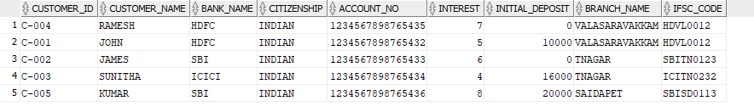

13.*Write a query which will display customer id, customer name, date of birth, guardian name, contact number,

mail id and reference account holder's name of the customers who has submitted the passport as an identification document.

SELECT C.CUSTOMER_ID,C.CUSTOMER_NAME,C.DATE_OF_BIRTH,C.GUARDIAN_NAME,C.CONTACT_NO,C.MAIL_ID,R.REFERENCE_ACC_NAME

FROM CUSTOMER_PERSONAL_INFO C,CUSTOMER_REFERENCE_INFO R

WHERE C.CUSTOMER_ID=R.CUSTOMER_ID AND IDENTIFICATION_DOC_TYPE ='PASSPORT' ;

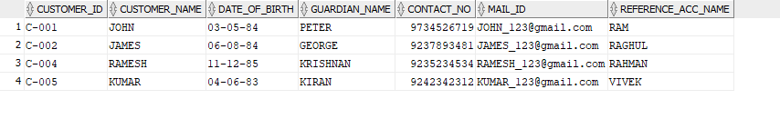

14.*Write a query to display the customer id, customer name, account number, account type, initial deposit,

interest who have deposited maximum amount in the bank.

SELECT C.CUSTOMER_ID,C.CUSTOMER_NAME,A.ACCOUNT_NO,A.ACCOUNT_TYPE,A.INITIAL_DEPOSIT,A.INTEREST

FROM CUSTOMER_PERSONAL_INFO C,ACCOUNT_INFO A

WHERE C.CUSTOMER_ID=A.CUSTOMER_ID AND INITIAL_DEPOSIT=(SELECT MAX(INITIAL_DEPOSIT) FROM ACCOUNT_INFO);

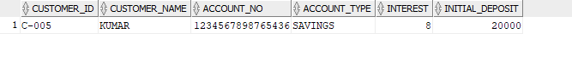

15.*Write a query to display the customer id, customer name, account number, account type, interest, bank name

and initial deposit amount of the customers who are getting maximum interest rate.

SELECT C.CUSTOMER_ID,C.CUSTOMER_NAME,A.ACCOUNT_NO,A.ACCOUNT_TYPE,A.INTEREST,B.BANK_NAME,A.INITIAL_DEPOSIT

FROM CUSTOMER_PERSONAL_INFO C,ACCOUNT_INFO A,BANK_INFO B

WHERE C.CUSTOMER_ID=A.CUSTOMER_ID AND A.IFSC_CODE=B.IFSC_CODE AND INTEREST=(SELECT MAX(INTEREST) FROM ACCOUNT_INFO);

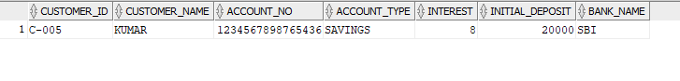

16.Write a query to display the customer id, customer name, account no, bank name, contact no

and mail id of the customers who are from BANGALORE.

SELECT C.CUSTOMER_ID,C.CUSTOMER_NAME,A.ACCOUNT_NO,B.BANK_NAME,C.CONTACT_NO,C.MAIL_ID

FROM CUSTOMER_PERSONAL_INFO C,ACCOUNT_INFO A,BANK_INFO B

WHERE C.CUSTOMER_ID=A.CUSTOMER_ID AND A.IFSC_CODE=B.IFSC_CODE AND C.ADDRESS LIKE '%BANGALORE%';

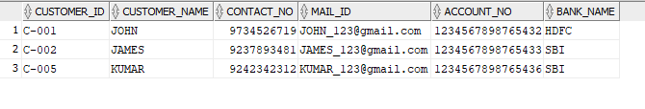

17.Write a query which will display customer id, bank name, branch name, ifsc code, registration date,

activation date of the customers whose activation date is in the month of march (March 1'st to March 31'st).

SELECT A.CUSTOMER_ID,B.BANK_NAME,B.BRANCH_NAME,B.IFSC_CODE,A.REGISTRATION_DATE,A.ACTIVATION_DATE

FROM BANK_INFO B,ACCOUNT_INFO A

WHERE TO_CHAR(ACTIVATION_DATE,'mm')='03' ;

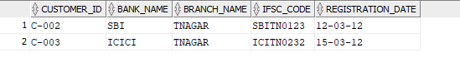

18.Write a query which will calculate the interest amount and display it along with customer id, customer name,

account number, account type, interest, and initial deposit amount.<BR>Hint :Formula for interest amount,

calculate: ((interest/100) * initial deposit amt) with column name 'interest_amt' (alias).

SELECT C.CUSTOMER_ID,C.CUSTOMER_NAME,A.ACCOUNT_NO,A.ACCOUNT_TYPE,A.INTEREST,A.INITIAL_DEPOSIT,((A.INTEREST/100)*A.INITIAL_DEPOSIT) AS INTEREST_AMT

FROM CUSTOMER_PERSONAL_INFO C,ACCOUNT_INFO A

WHERE C.CUSTOMER_ID=A.CUSTOMER_ID;

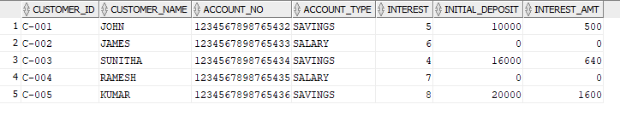

19.Write a query to display the customer id, customer name, date of birth, guardian name, contact number,

mail id, reference name who has been referenced by 'RAGHUL'.

SELECT C.CUSTOMER_ID,C.CUSTOMER_NAME,C.DATE_OF_BIRTH,C.GUARDIAN_NAME,C.CONTACT_NO,C.MAIL_ID,R.REFERENCE_ACC_NAME

FROM CUSTOMER_PERSONAL_INFO C, CUSTOMER_REFERENCE_INFO R

WHERE R.CUSTOMER_ID = C.CUSTOMER_ID AND R.REFERENCE_ACC_NAME = 'RAGHUL';

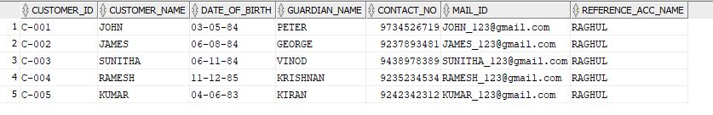

20."Write a query which will display the customer id, customer name and contact number with ISD code of

all customers in below mentioned format. Sort the result based on the customer id in descending order.

<BR>Format for contact number is :

<br/> ""+91-3digits-3digits-4digits""

<br/> Example: +91-924-234-2312

<br/> Use ""CONTACT_ISD"" as alias name."

SELECT CUSTOMER_ID, CUSTOMER_NAME, DATE_OF_BIRTH, '+91-' || SUBSTR(CONTACT_NO, 1, 3) || '-' || SUBSTR(CONTACT_NO, 4, 3) || '-' ||SUBSTR(CONTACT_NO, 7) AS CONTACT_ISD

FROM CUSTOMER_PERSONAL_INFO ORDER BY CUSTOMER_ID DESC;

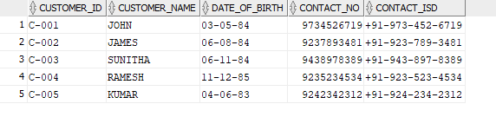

21.Write a query which will display account number, account type, customer id, customer name, date of birth, guardian name,

contact no, mail id , gender, reference account hlders name, reference account holders account number, registration date,

activation date, number of days between the registration date and activation date with alias name "NoofdaysforActivation",

bank name, branch name and initial deposit for all the customers.

SELECT A.ACCOUNT_NO,A.ACCOUNT_TYPE,A.CUSTOMER_ID,C.CUSTOMER_NAME,C.DATE_OF_BIRTH,C.GUARDIAN_NAME,C.CONTACT_NO,C.MAIL_ID,C.GENDER,R.REFERENCE_ACC_NAME,R.REFERENCE_ACC_NO,A.REGISTRATION_DATE,A.ACTIVATION_DATE,(A.ACTIVATION_DATE - A.REGISTRATION_DATE) AS NoofdaysforActivation,B.BANK_NAME,B.BRANCH_NAME,A.INITIAL_DEPOSIT

FROM ACCOUNT_INFO A,

CUSTOMER_PERSONAL_INFO C,

CUSTOMER_REFERENCE_INFO R,

BANK_INFO B

WHERE A.CUSTOMER_ID = C.CUSTOMER_ID

AND R.CUSTOMER_ID =C.CUSTOMER_ID

AND A.IFSC_CODE=B.IFSC_CODE;



22."Write a query which will display customer id, customer name, guardian name, identification doc type,

reference account holders name, account type, ifsc code, bank name and current balance for the customers

who has only the savings account.

<br/>Hint: Formula for calculating current balance is add the intital deposit amount and interest

and display without any decimals. Use ""CURRENT_BALANCE"" as alias name."

SELECT C.CUSTOMER_ID,C.CUSTOMER_NAME,C.GUARDIAN_NAME,C.IDENTIFICATION_DOC_TYPE,R.REFERENCE_ACC_NAME,A.ACCOUNT_TYPE,A.IFSC_CODE,B.BANK_NAME,ROUND(A.INITIAL_DEPOSIT+A.INTEREST) AS CURRENT_BALANCE

FROM CUSTOMER_PERSONAL_INFO C,BANK_INFO B,ACCOUNT_INFO A,CUSTOMER_REFERENCE_INFO R

WHERE C.CUSTOMER_ID=R.CUSTOMER_ID AND C.CUSTOMER_ID=A.CUSTOMER_ID AND A.IFSC_CODE=B.IFSC_CODE AND ACCOUNT_TYPE='SAVING';



23."Write a query which will display the customer id, customer name, account number, account type, interest, initial deposit;

<br/>check the initial deposit,<br/> if initial deposit is 20000 then display ""high"",<br/> if initial deposit is 16000 display 'moderate'

,<br/> if initial deposit is 10000 display 'average', <br/>if initial deposit is 5000 display 'low', <br/>if initial deposit is 0 display

'very low' otherwise display 'invalid' and sort by interest in descending order.<br/>

Hint: Name the column as ""Deposit_Status"" (alias).

<br/>Strictly follow the lower case for strings in this query."

SELECT C.CUSTOMER_ID,C.CUSTOMER_NAME,A.ACCOUNT_NO,A.ACCOUNT_TYPE,A.INTEREST,A.INITIAL_DEPOSIT,

CASE AC.INITIAL_DEPOSIT

WHEN 20000 THEN 'HIGH'

WHEN 16000 THEN 'MODERATE'

WHEN 10000 THEN 'AVERAGE'

WHEN 5000 THEN 'LOW'

WHEN 0 THEN 'VERY LOW'

END DEPOSIT_STATUS

FROM ACCOUNT_INFO A,CUSTOMER_PERSONAL_INFO C

WHERE A.CUSTOMER_ID = C.CUSTOMER_ID;

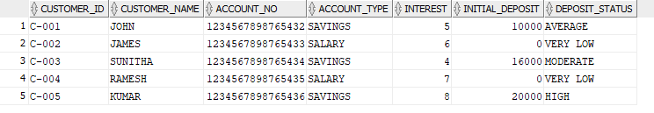

24."Write a query which will display customer id, customer name, account number, account type, bank name, ifsc code, initial deposit amount

and new interest amount for the customers whose name starts with ""J"".

<br/> Hint: Formula for calculating ""new interest amount"" is

if customers account type is savings then add 10 % on current interest amount to interest amount else display the current interest amount.

Round the new interest amount to 2 decimals.<br/> Use ""NEW_INTEREST"" as alias name for displaying the new interest amount.

<br/>Example, Assume Jack has savings account and his current interest amount is 10.00, then the new interest amount is 11.00 i.e (10 + (10 * 10/100)).

SELECT C.CUSTOMER_ID,C.CUSTOMER_NAME,A.ACCOUNT_NO,A.ACCOUNT_TYPE,B.BANK_NAME,B.IFSC_CODE,A.INITIAL_DEPOSIT,

CASE A.ACCOUNT_TYPE

WHEN 'SAVINGS' THEN A.INTEREST + (A.INTEREST * 10/100)

ELSE A.INTEREST

END AS NEW_INTEREST

FROM BANK_INFO B,

CUSTOMER_PERSONAL_INFO C,

ACCOUNT_INFO A

WHERE C.CUSTOMER_ID = A.CUSTOMER_ID

AND A.IFSC_CODE = B.IFSC_CODE;

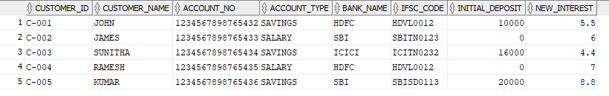

25.Write query to display the customer id, customer name, account no, initial deposit, tax percentage as calculated below.

<BR>Hint: <BR>If initial deposit = 0 then tax is '0%'<BR>If initial deposit &lt;= 10000 then tax is '3%'

<BR>If initial deposit &gt; 10000 and initial deposit &lt; 20000 then tax is '5%' <BR>If initial deposit &gt;= 20000 and

initial deposit&lt;=30000 then tax is '7%' <BR>If initial deposit &gt; 30000 then tax is '10%' <BR>Use the alias name 'taxPercentage'

SELECT C.CUSTOMER_ID,C.CUSTOMER_NAME,A.ACCOUNT_NO,A.INITIAL_DEPOSIT,

CASE

WHEN A.INITIAL_DEPOSIT >= 30000 THEN '7%'

WHEN A.INITIAL_DEPOSIT >= 20000 THEN '5%'

WHEN A.INITIAL_DEPOSIT >= 10000 THEN '3%'

WHEN A.INITIAL_DEPOSIT >= 0 THEN '0%'

END AS taxPercentage

FROM BANK_INFO B,CUSTOMER_PERSONAL_INFO C,ACCOUNT_INFO A

WHERE C.CUSTOMER_ID = A.CUSTOMER_ID

AND AC.IFSC_CODE = B.IFSC_CODE;

